***Practicals – 10***

*-BS19B032*

*-R. Vasantha Kumar*

1) As per the given hints in the question and the detailed steps in the presentation given, I obtained phylogenetic trees for the given datasets.

For each dataset, I obtained four trees:

* Normal Phylogenetic tree
* Consensus Phylogenetic tree
* NJ Phylogenetic tree
* Consensus NJ Phylogenetic tree

For viewing the trees obtained, I downloaded Treeview X program. Files are attached in submission.

***For set1: tim.dat –***

***Normal Phylogenetic tree: outtree***

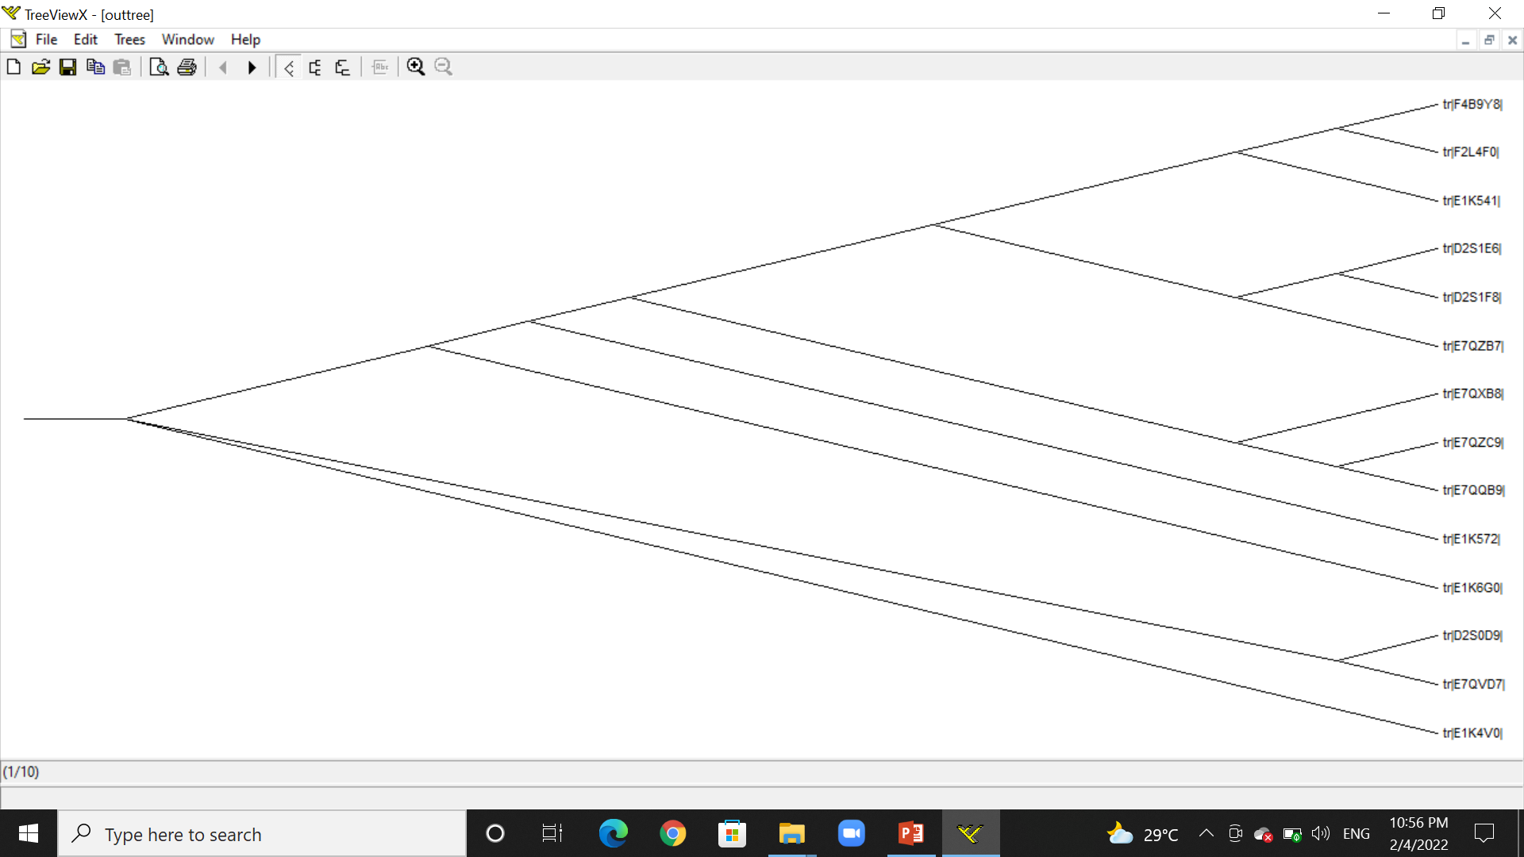

***Consensus Phylogenetic tree: work1constree***

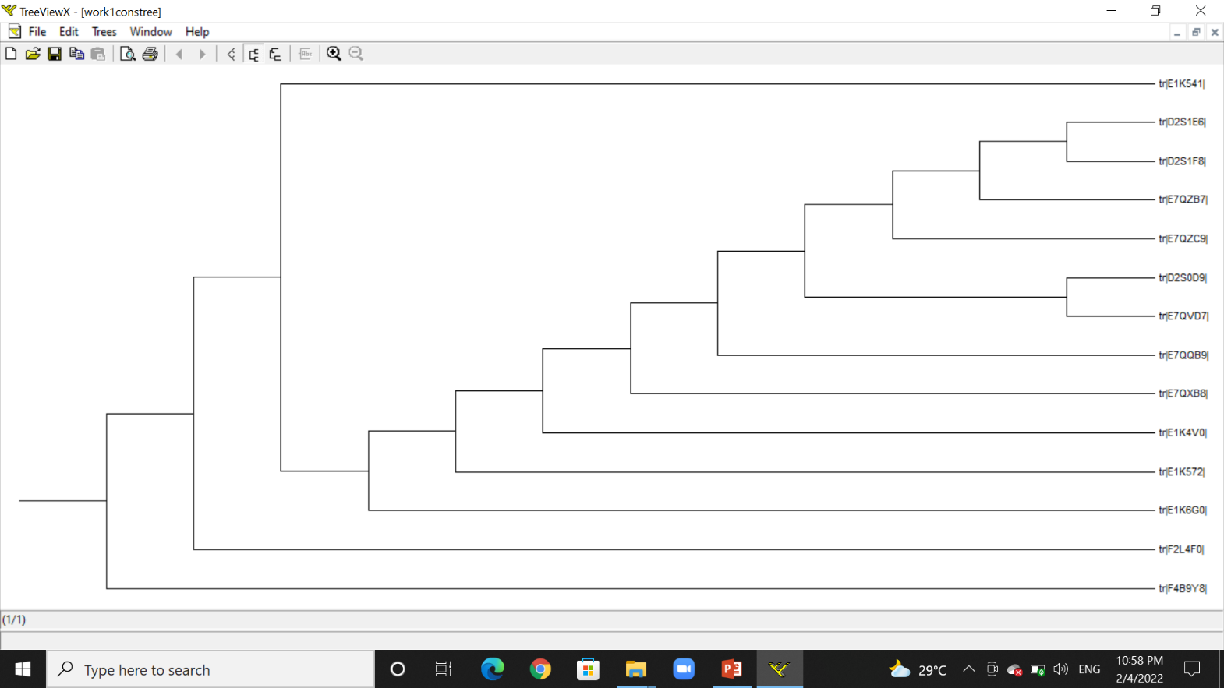

***NJ Phylogenetic tree: work1-nj-tree***

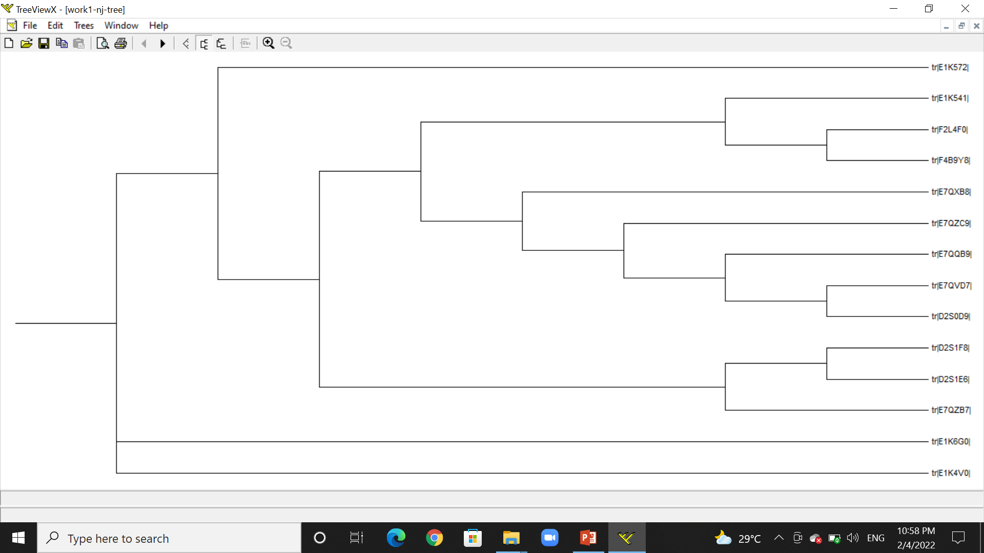

***Consensus NJ Phylogenetic tree: work1-nj-constree***

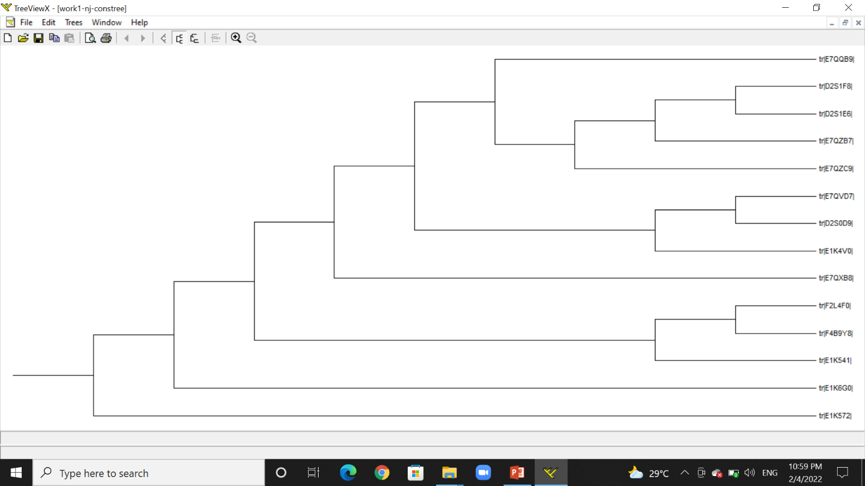

***For set2: tim-hemo.dat –***

***Normal Phylogenetic tree: outtree1***

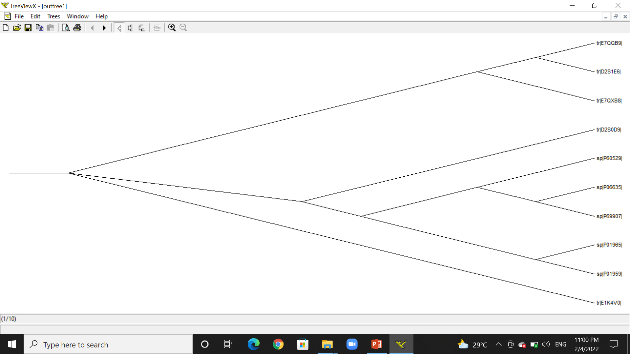

***Consensus Phylogenetic tree: work2constree***

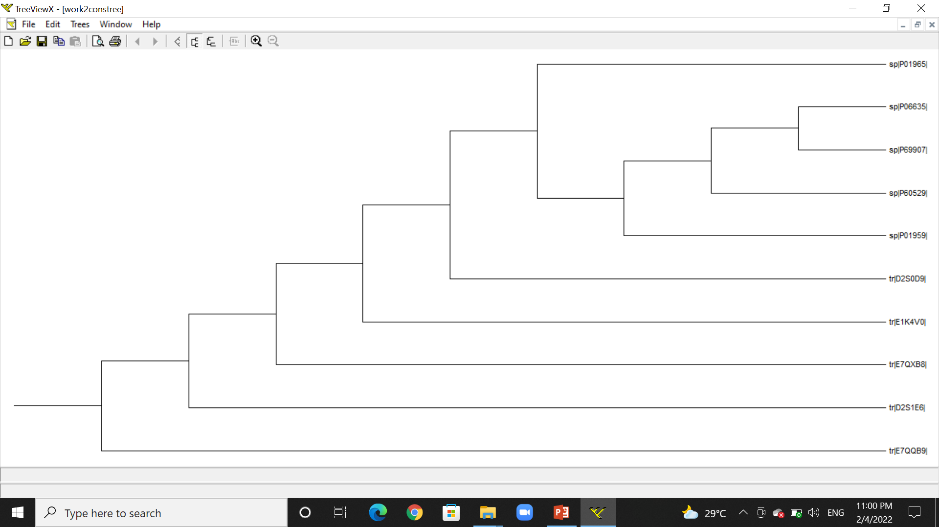

***NJ Phylogenetic tree: work2-nj-tree***

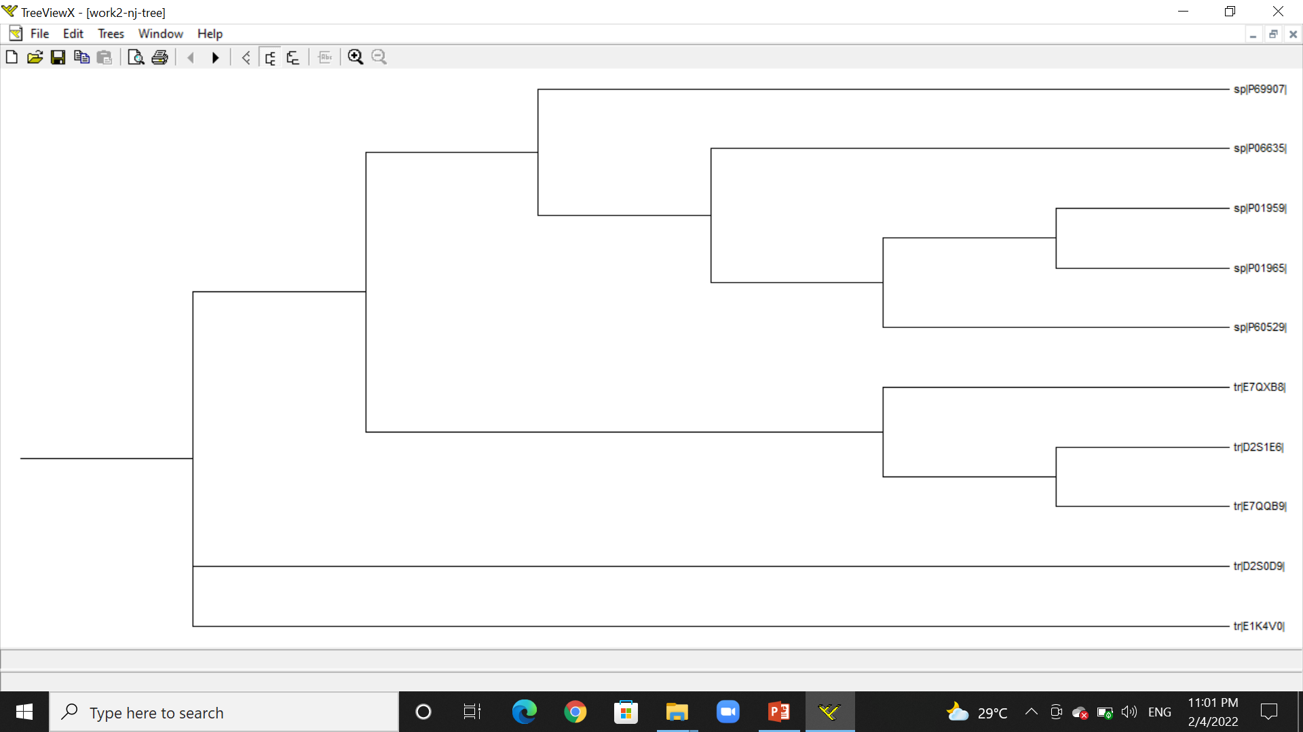

***Consensus NJ Phylogenetic tree: work2-nj-constree***

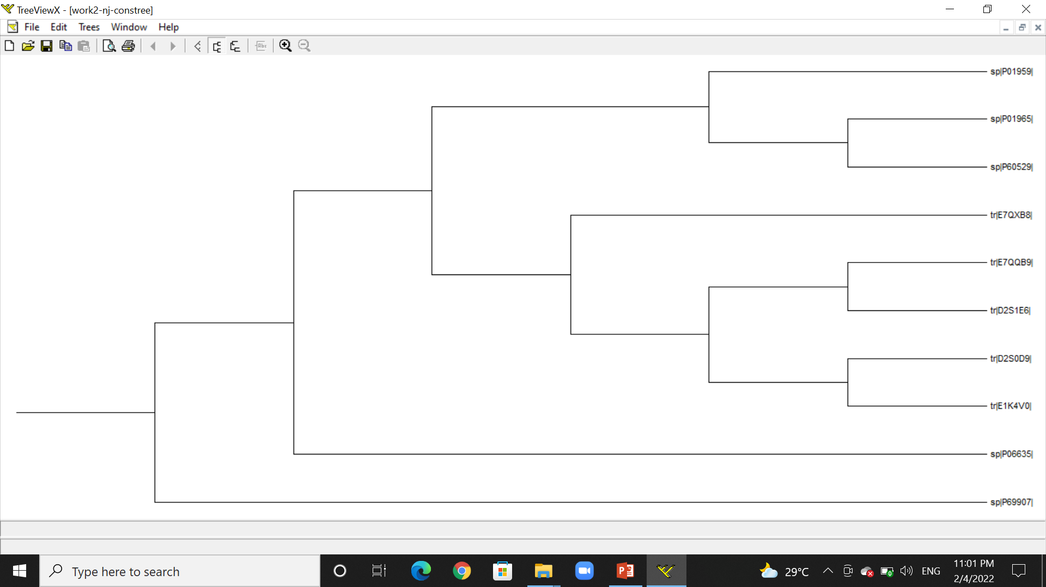

2) I wrote a code to create the weight matrix for the given sequences using the given formula. I attached the code in submission.(weight_matrix.py)

w[i][j] = ln(((ni,j + 0.05)/(N+1))/0.05)

ni,j = frequency of amino acid i, in position j.

0.05 = 1/20, since, total amino acids = 20

N = total number of sequences

I attached the weight matrix as an excel file in submission. (w_mat.xlsx)